**COMET BAY COLLEGE**

**Physics - Unit 2 - Task 8**

**Practical Exam**

**Name: Total Marks /60**

Note: Show working for all mathematical answers.

**Question 1**

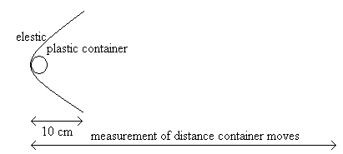

*Figure 2*

Rachael is conducting an experiment to find out how the weight effects the distance a plastic container can travel along a mostly smooth surface.

She clamps a piece of elastic across a desk and pulls it back 10 cm. She measures this distance using a ruler that measures in millimetres. She places a plastic container on a scale that measures at 100 gram intervals and finds that the container weighs 0.1 kg. She holds the container with the elastic before releasing the elastic. The plastic container slides along the surface until it stops and the distance was measured. The experiment was repeated twice more. See Figure 2.

She then repeated the experiment using 0.2 kg, 0.3 kg, 0.4 kg and 0.5 kg weighted containers.

a) (i) State the independent variable: __________________________________ **(1 mark)**

(ii) State the dependent variable: ____________________________________ **(1 mark)**

(iii) List two controlled variables: **(2 marks)**

b) Write the prediction component only for the hypothesis for this experiment. **(2 marks)**

________________________________________________________________________________________________________________________________________________________________________________________________________________________________________________________________________________________________________

c) List two uncertainties that could be considered in this experiment? Name the uncertainty (error) and assign a ± value of the uncertainty based on the information given above

**(2 marks)**

d) She collected her results and recorded them below. Complete the table. **(4 marks)**

|  |  |  |  |  |  |
| --- | --- | --- | --- | --- | --- |
| **Total weight (kg)** | **Distance travelled (m)** | | | **AVERAGE (m)** | **±uncertainty** |
| **Trial 1** | **Trial 2** | **Trial 3** |
| 0.1 | 0.49 | 0.43 | 0.46 |  |  |
| 0.2 | 0.37 | 0.40 | 0.42 |  |  |
| 0.3 | 0.32 | 0.33 | 0.31 |  |  |
| 0.4 | 0.29 | 0.32 | 0.27 |  |  |
| 0.5 | 0.25 | 0.25 | 0.27 |  |  |
| 0.6 | 0.19 | 0.10 | 0.21 |  |  |

**Question 2**

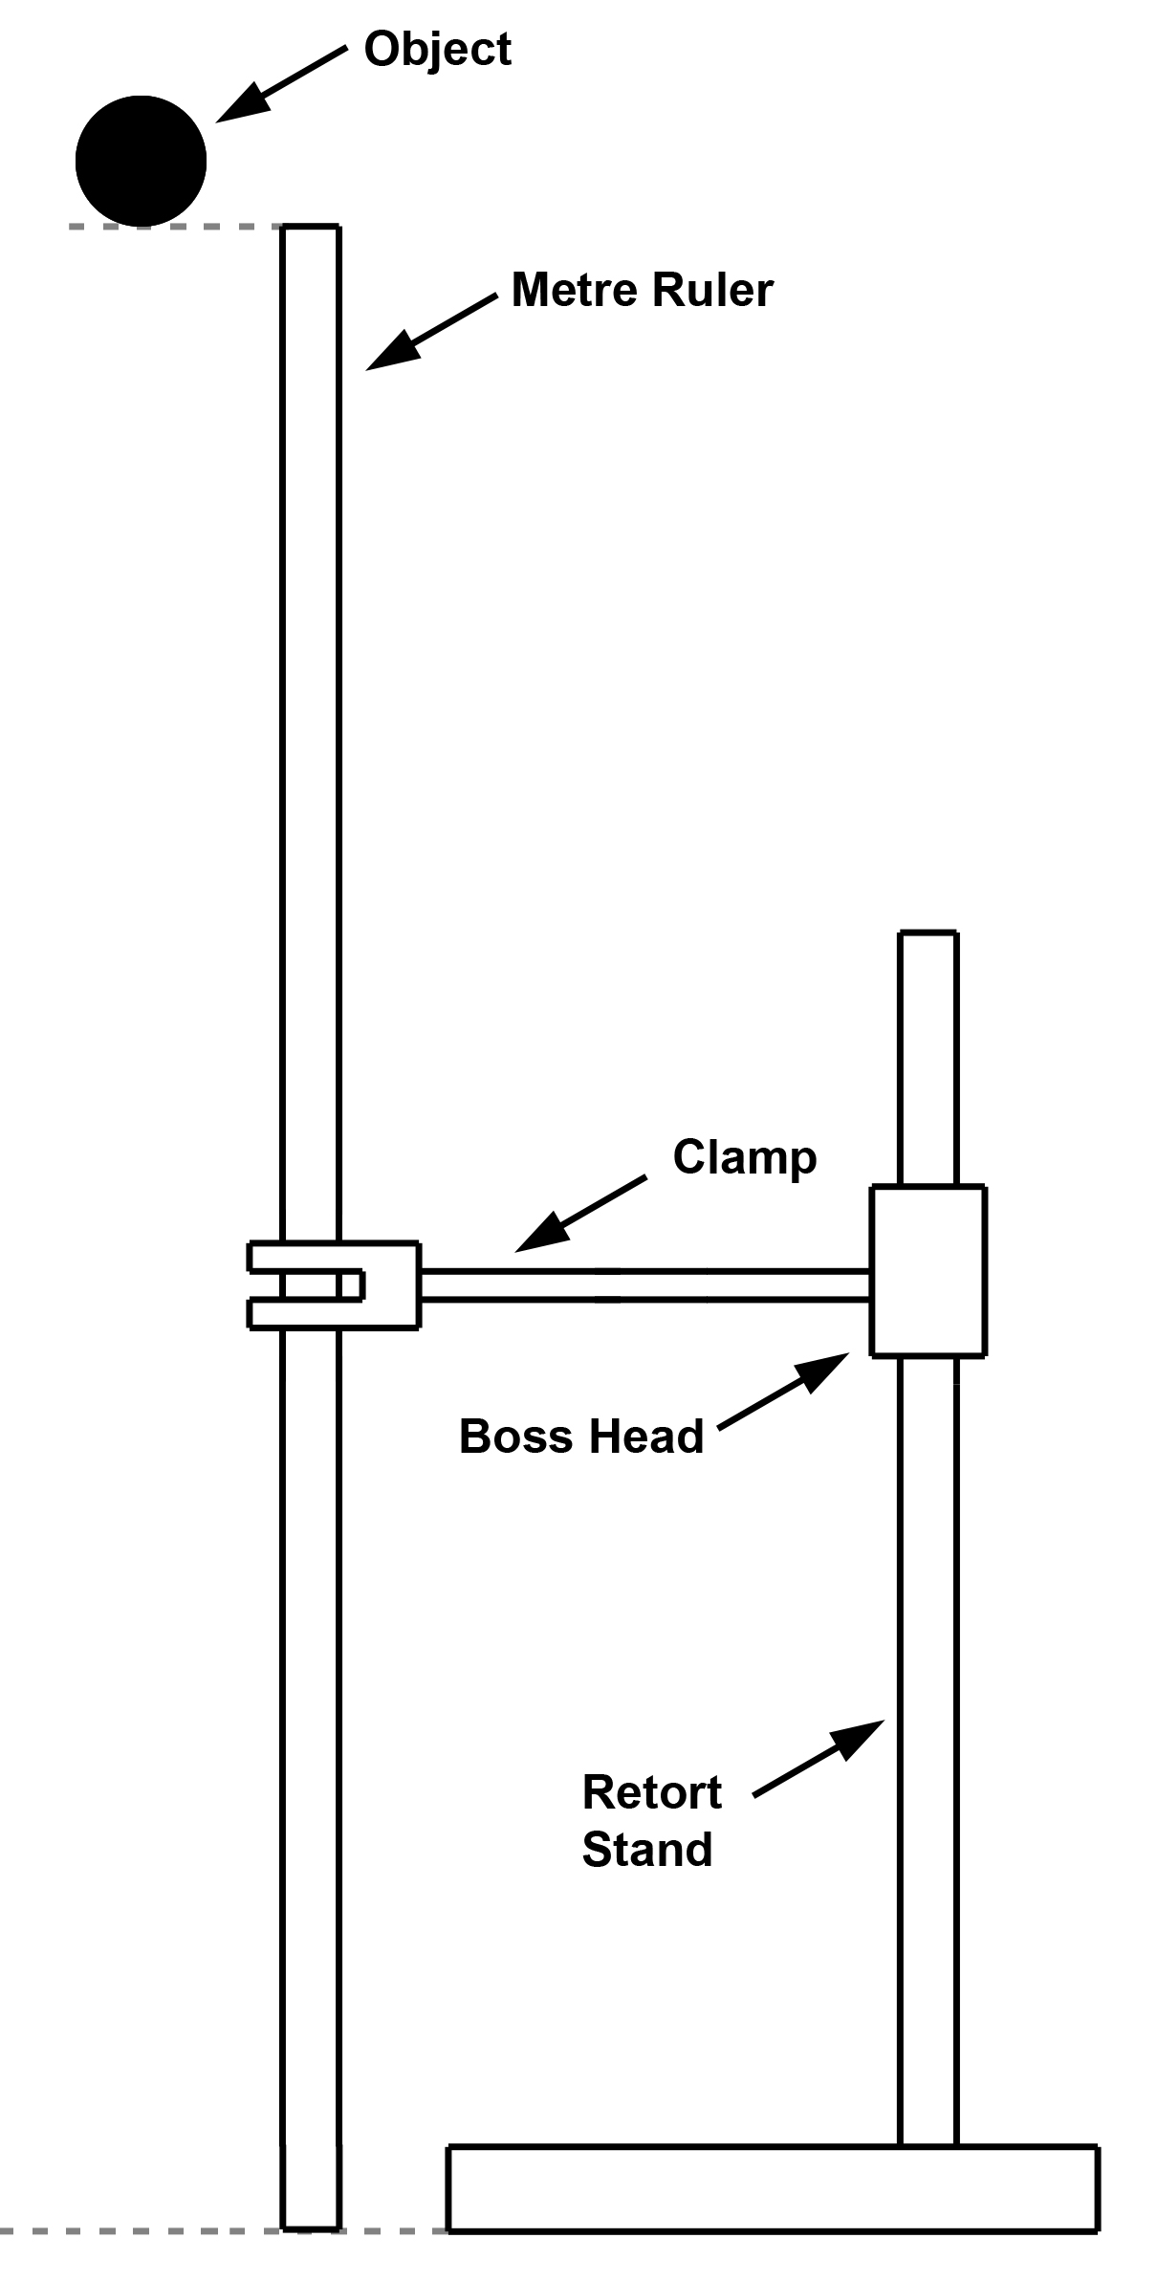

*Figure 1*

Two students were carrying out an experiment where the aim was to investigate the possible relationship between Gravitational Potential energy and Kinetic Energy. This was achieved by dropping an object from a height of one metre (*Figure 1*) and recording the speed of that object at select intervals before impact using a data-logger.

In carrying out the experiment, the students obtained the following set of data, as shown below:

|  |  |  |
| --- | --- | --- |
| Mass of ball (g) | Height at where speed was recorded **(from start point)** | Speed (m s-1) |
| 150.0 g | 15 cm | 0.984 |
| 150.0 g | 35 cm | 2.099 |
| 150.0 g | 55 cm | 2.827 |
| 150.0 g | 75 cm | 3.412 |
| 150.0 g | 95 cm | 3.840 |

a) Calculate the Gravitational Potential energy (Ep) and the Kinetic energy (Ek) at the initial point of release. **(4 marks)**

From the data collected the students decided to produce a new table that would better explain the energy transformations. Complete the following table. This new table shows the **heights from the base**.

b) Complete the table **(5 marks)**

|  |  |  |  |  |
| --- | --- | --- | --- | --- |
| Height from base (m) | Potential Energy (J) | Speed (m s-1) | Kinetic Energy (J) | Mechanical Energy (= KE + PE) (J) |
| 1.00 |  |  |  |  |
| 0.85 |  |  |  |  |
| 0.65 |  |  |  |  |
| 0.45 |  |  |  |  |
| 0.25 |  |  |  |  |
| 0.05 |  |  |  |  |

c) For the results obtained in the Mechanical Energy section, explain whether this is what you would expect and why. **(3 marks)**

____________________________________________________________________________________________________________________________________________________________________________________________________________________________________________________________________________________________________________________________________________________________________________________________________________________________________________________________________________________________________________________________________________________________________________________________________________________________________________________________________________________________________________________________________________________________________

d) What conclusion can be made relating to the aim of the experiment based on the data obtained? **(2 marks)**

____________________________________________________________________________________________________________________________________________________________________________________________________________________________________________________________________________________________________________________________________________________________________________________________________________________________________________________________

**Question 3**

A student rolled a toy car down a ramp. The ramp was 4.0 m long and the student placed the ramp at an angle to the desk. He then marked off sections of the ramp to show when he would record the displacement and time (See Figure 1: Ramp). He also noted that in the first 2 seconds the toy car experienced acceleration before continuing down the ramp at constant velocity.

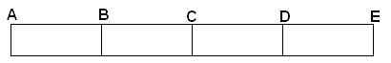

*Figure 1: Ramp*

He obtained the results shown below:

|  |  |  |  |  |  |
| --- | --- | --- | --- | --- | --- |
| Sections of Ramp | A | B | C | D | E |
| Total displacement from start (m) | 0 | 1.0 | 2.0 | 3.0 | 4.0 |
| Total time (s) | 0 | 3.16 | 5.61 | 8.04 | 10.52 |

1. On the graph below, graph the total distance versus total time and draw a line of best fit starting at 2 seconds. Also sketch the acceleration component on the graph for the first 2 seconds **(5 marks)**

b) Use the graph to calculate the gradient of the line between 2.0 m and 4.0 m. Show coordinates used and units of measurement. **(3 marks)**

**Question 4**

Read the information below then answer the following questions.

**Background Information:**

The period of a pendulum can be found using the following equation:

T = 2 $π\sqrt{\left(\frac{l}{g}\right)}$ where T = period of oscillation (swing back and forth)

ℓ= length of the string

g = acceleration due to gravity; 9.8 ms-2

***Hypothesis:***

*The period of oscillation of a pendulum is independent of the mass on the pendulum, therefore if the mass is increased, the period will remain constant within experimental error.*

* + - * 1. Jane conducted the experiment to investigate if the hypothesis above was true by increasing the mass and measuring the period for each different mass. Her results are recorded in the table below.

Length of string: 82.6 cm

|  |  |  |  |  |
| --- | --- | --- | --- | --- |
| **Mass** | **Time for 10 complete swings** | | **Average for 10 swings** | **Period** |
| **Trial 1** | **Trial 2** |
| 150g | 17.23 | 19.03 |  |  |
| 200g | 18.68 | 17.86 |  |  |
| 300g | 18.21 | 18.13 |  |  |

1. Complete the table above. **(3 marks)**
2. What is the average period for the different masses (no working required)? **(1 mark)**
3. Determine the theoretical time period for the pendulum. **(2 marks)**
   * + - 1. What is the percentage error between the practical and theoretical results? **(2 marks)**
         2. Write a discussion for this experiment. **(10 marks)**

______________________________________________________________________________________________________________________________________________________________________________________________________________________________________________________________________________________________________________________________________________________________________________________________________________________________________________________________________________________________________________________________________________________________________________________________________________________________________________________________________________________________________________________________________________________________________________________________________________________________________________________________________________________________________________________________________________________________________________________________________________________________________________________________________________________________________________________________________________________________________________________________________________________________________________________________________________________________________________________________________________________________________________________________________________________________________________________________________________________________________________________________________________________________________________________________________________________________________________________________________________________________________________________________________________________________________________________________________________________________________________________________________________________________________________________________________________________________________________________________________________________________________________________________________________________________________________________________________________________________________________________________________________________________________________________________________________________________________________________________________________________________________________________

**Question 5**

Samantha was trying to find the speed of sound within an open tube. She set up the equipment shown and recorded the distances between maximum frequency readings using the cathode ray oscilloscope (CRO). She recorded her results in the table below.

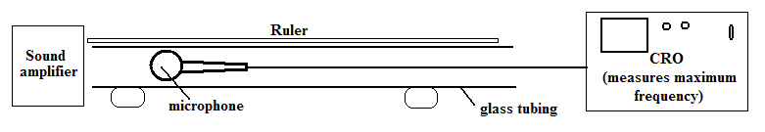

|  |  |  |  |
| --- | --- | --- | --- |
| **Frequency**  **(Hz)** | **Distance between maximum freq. (cm)** | **Wavelength**  **(m)** | **Speed of sound (ms-1)** |
| 200 | 84.5 |  |  |
| 500 | 68.0 |  |  |
| 800 | 21.2 |  |  |
| 1100 | 15.4 |  |  |

1. Complete the wavelength column in the table showing your calculations for 200 Hz below.

**(3 marks – 2 marks for 200 Hz calculations and 1 mark for all others shown in table)**

1. Show your calculation for the speed of sound for 200 Hz below, then complete the last column in the table.

**(3 marks – 2 marks for 200 Hz calculations and 1 mark for all others shown in table)**

1. What value did Samantha get for the speed of sound? **(2 marks)**